 Rationalist Think Tank

A discussion meet up for members of the Rationalist Society of Australia or those who think they can think like a rationalist should.

Report on “Is the Australian Tax System Fair?”
The Rationalist Think Tank met on June 12th to discuss the Australian Taxation System. The topic is complex so we targeted negative gearing, capital gains and the personal income tax tables.
Negative Gearing
It was agreed that the current laws should be changed. Some members proposed that negative gearing be phased out for all properties but others wanted the system retained for new properties up to a limit of 2 or 3 per tax payer. It was agreed losses should be carried forward for offsetting future profits.
Capital Gains Tax
There was no support for the current 50% discount applying to capital gains on assets held for more than 1 year. There was general agreement that a CPI adjustment on the purchase cost could be introduced for assets held in excess of 2 years.
On the basis that it is preferable to tax wealth rather than wages it was proposed that an inheritance tax be reintroduced.
Personal income Tax Tables
At the lower income level there were two proposals. 1. Raise the income before tax is payable (currently $18,200 per year). 2. Introduce an additional level of $28,000 at 26%.
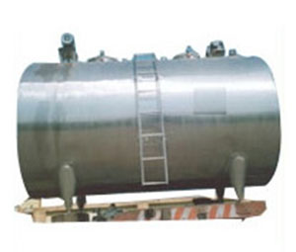

At the top income level there was a proposal to introduce an additional level above $180,000 at a higher tax rate. It was agreed that the top of the tax table should be adjusted if an inheritance tax was introduced or land tax changed to increase tax receipts.

